Accessibility conformance test report
Page evaluated:html web page given
Evaluator: SammarAbbas

Summary of the conformance test
The conformance test was performed using the WAVE accessibility evaluation tool, which analysed the structure, perceivability of the webpage. The tool identified 7 errors, 21 alerts, and 3 contrast errors, which shows that the page does not fully meet WCAG 2.1 AA conformance requirements. The page received a 5/10 AIM score which tells there are some need of improvements in terms of accessibility .
Some errors are missing alternative text, missing form labels, invalid or missing language declaration, an empty button, and an empty link. These issues affect users who rely on assistive technologies such as screen readers and can interfere with navigation, comprehension, and interaction. Alerts also highlighted structural concerns, including missing headings and suspicious or potentially redundant links, which may create confusion for keyboard-only or screen reader users.
To summarize, the results indicate that while the page contains some accessible elements, significant updates are needed to ensure full compliance, improve usability, and provide an inclusive experience for all users.

Results of the conformance test
Note that the information you will be reporting is in your own words but is based on the ‘Details’ and ‘Reference’ sections in your WAVE conformance test results report.
Missing alternative text | 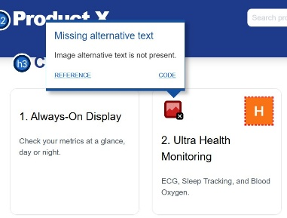 | Missing alt text is an issue because screen reader users cannot understand the image’s content without a text alternative. | Provide a clear, descriptive alt attribute for every meaningful image so screen readers can convey its purpose or content to users. | What level of conformance does it break?  WCAG 2.1 Level A
Empty button | 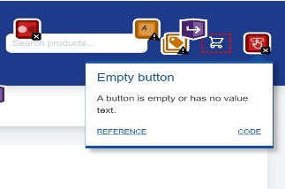 | Because screen readers cannot determine the button’s purpose, making it unusable for non-visual users. | Add meaningful text or an accessible name | It breaks WCAG 2.1 Level A

